**The Record of Assignment Process**

**Date …….../…....../……...**

**Project Name ………………………………………..**

**Project Manager ……………………….……………**

**Developer ………………………….…………………**

**Tester …………………….…………………………...**

**Deadline ……………………………..…….…… Project period ……………………….……**

|  |  |  |  |
| --- | --- | --- | --- |
|  | **Start Date** | **End Date** | **Total Period (hr)** |
| **Developer** |  |  |  |
| **Tester** |  |  |  |

|  |  |  |  |  |
| --- | --- | --- | --- | --- |
| **Order** | **Position** | **Time (hr)** | **Date** | **Comment** |
|  |  |  |  |  |
|  |  |  |  |  |
|  |  |  |  |  |
|  |  |  |  |  |

**Working Process**

**Developer**

**Tester**

0%

0%

|  |  |  |  |  |  |  |  |
| --- | --- | --- | --- | --- | --- | --- | --- |
| **7** | **Plan and design project scope** | 25/01/2017 | 01/02/2017 | 1 | 25/01/2017 | 01/02/2017 | 1 |
| **8** | **Design the system structure and UI** | 25/01/2017 | 01/02/2017 | 1 | 25/01/2017 | 08/02/2017 | 2 |
| **9** | **Prepare scope and design document for presentation with stakeholder** | 25/01/2017 | 01/02/2017 | 1 | 09/02/2017 | 16/02/2017 | 1 |
| **10** | **Send scope and designed document for presentation with stakeholder** | 02/02/2017 | 09/02/2017 | 1 | 09/02/2017 | 16/02/2017 | 1 |
| **11** | **Listen comment and edit document following stakeholder’s comment** | 02/02/2017 | 09/02/2017 | 1 | 09/02/2017 | 16/02/2017 | 1 |
| **12** | **Resend the edited document** | 10/02/2017 | 17/02/2017 | 1 | 17/02/2017 | 24/02/2017 | 1 |
| **13** | **Develop prototype software** | 18/02/2017 | 04/03/2017 | 2 | 25/02/2017 | 11/03/2017 | 2 |
| **14** | **Debug prototype software** | 25/02/2017 | 04/03/2017 | 1 | 04/03/2017 | 11/03/2017 | 1 |
| **15** | **Present prototype software to stakeholder** | 05/03/2017 | 12/03/2017 | 1 | 12/03/2017 | 19/03/2017 | 1 |
| **16** | **Listen comment and edit document following stakeholder’s comment** | 05/03/2017 | 12/03/2017 | 1 | 12/03/2017 | 19/03/2017 | 1 |
| **17** | **Modify the software following stakeholder’s comment** | 05/03/2017 | 19/03/2017 | 2 | 20/03/2017 | 27/03/2017 | 1 |
| **18** | **Debug modified software** | 12/03/2017 | 19/03/2017 | 1 | 20/03/2017 | 27/03/2017 | 1 |
| **19** | **Present modified software to stakeholder** | 20/03/2017 | 27/03/2017 | 1 | 28/03/2017 | 04/04/2017 | 1 |
| **20** | **Test case scenario** | 20/03/2017 | 27/03/2017 | 1 | 28/03/2017 | 04/04/2017 | 1 |
| **21** | **Install software completely** | 28/03/2017 | 04/04/2017 | 1 | 28/03/2017 | 04/04/2017 | 1 |
| **22** | **Prepare and transfer data to stakeholder** | 28/03/2017 | 04/04/2017 | 1 | 28/03/2017 | 04/04/2017 | 1 |
| **23** | **Send the user manual to stakeholder** | 28/03/2017 | 04/04/2017 | 1 | 28/03/2017 | 04/04/2017 | 1 |
| **24** | **Training software to user** | 05/04/2017 | 12/04/2017 | 1 | 05/04/2017 | 12/04/2017 | 1 |

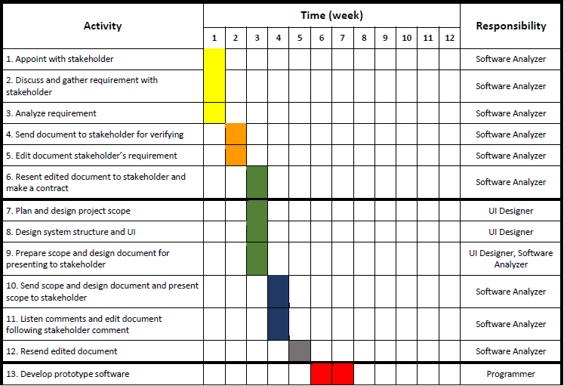

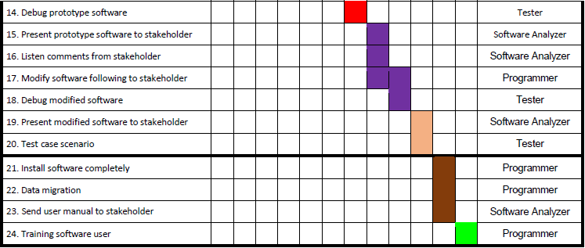

|  |  |  |  |  |  |  |  |  |  |  |  |  |  |
| --- | --- | --- | --- | --- | --- | --- | --- | --- | --- | --- | --- | --- | --- |
| **Activity** | **Time (week)** | | | | | | | | | | | | **Responsible** |
| **1.Appoint with stakeholder** |  |  |  |  |  |  |  |  |  |  |  |  | **Software Analyzer** |
| **Requirement Process** | | | | | | | | | | | | | |
| **2.Discuss and gather requirement with stakeholder** |  |  |  |  |  |  |  |  |  |  |  |  | **Software Analyzer** |
| **3.Analyze the requirement** |  |  |  |  |  |  |  |  |  |  |  |  | **Software Analyzer** |
| **4. Send the document to stakeholder for verification** |  |  |  |  |  |  |  |  |  |  |  |  | **Software Analyzer** |
| **5. Edit the document about the stakeholder’s requirement** |  |  |  |  |  |  |  |  |  |  |  |  | **Software Analyzer** |
| **6. Resend the edited document to stakeholder and make a contract** |  |  |  |  |  |  |  |  |  |  |  |  | **Software Analyzer** |
| **Finish requirement process & Begin Design Process** | | | | | | | | | | | | | |
| **7. Plan and design project scope** |  |  |  |  |  |  |  |  |  |  |  |  | **UI Designer** |
| **8. Design the system structure and UI** |  |  |  |  |  |  |  |  |  |  |  |  | **UI Designer** |
| **9. Prepare scope and design document for presentation with stakeholder** |  |  |  |  |  |  |  |  |  |  |  |  | **UI Designer,Software Analyzer** |
| **10. Send scope and designed document for presentation with stakeholder** |  |  |  |  |  |  |  |  |  |  |  |  | **Software Analyzer** |
| **11. Listen comment and edit document following stakeholder’s comment** |  |  |  |  |  |  |  |  |  |  |  |  | **Software Analyzer** |
| **12. Resend the edited document** |  |  |  |  |  |  |  |  |  |  |  |  | **Software Analyzer** |
| **Finish design process & Begin Implementation** | | | | | | | | | | | | | |
| **13. Develop prototype software** |  |  |  |  |  |  |  |  |  |  |  |  | **Software Developer** |
| **14. Debug prototype software** |  |  |  |  |  |  |  |  |  |  |  |  | **Tester** |
| **15. Present prototype software to stakeholder** |  |  |  |  |  |  |  |  |  |  |  |  | **Software Analyzer** |
| **16. Listen comment and edit document following stakeholder’s comment** |  |  |  |  |  |  |  |  |  |  |  |  | **Software Analyzer** |
| **17. Modify the software following stakeholder’s comment** |  |  |  |  |  |  |  |  |  |  |  |  | **Software Developer** |
| **18. Debug modified software** |  |  |  |  |  |  |  |  |  |  |  |  | **Tester** |
| **19. Present modified software to stakeholder** |  |  |  |  |  |  |  |  |  |  |  |  | **Software Analyzer** |
| **Finish Implementation & Begin system migration** | | | | | | | | | | | | | |
| **20. Install software completely** |  |  |  |  |  |  |  |  |  |  |  |  | **Software Developer** |
| **21. Data migration** |  |  |  |  |  |  |  |  |  |  |  |  | **Software Developer** |
| **Finish system migration & Begin to test the software** | | | | | | | | | | | | | |
| **22. Test case scenario** |  |  |  |  |  |  |  |  |  |  |  |  | **Tester** |
| **Finish to test the software & Begin to sign contract** | | | | | | | | | | | | | |
| **23. Send the user manual to stakeholder** |  |  |  |  |  |  |  |  |  |  |  |  | **Software Analyzer** |
| **24. Training software to user** |  |  |  |  |  |  |  |  |  |  |  |  | **Software Developer** |
| **25. Sign contract** |  |  |  |  |  |  |  |  |  |  |  |  | **Software Analyzer** |